

# 

### Semester Two Examination, 2020

### Question/Answer booklet

# MATHEMATICS

If required by your examination administrator, please place your student identification label in this box

**APPLICATIONS**

**UNITS 3&4**

## Section One:

## Calculator-free

Your name _____________________________________

## Teacher’s Name _________________________________

|  |  |
| --- | --- |
| Number of additional answer booklets used (if applicable): |  |

## Time allowed for this section

Reading time before commencing work: five minutes

Working time: fifty minutes

## Materials required/recommended for this section

***To be provided by the supervisor***

This Question/Answer booklet

Formula sheet

***To be provided by the candidate***

Standard items: pens (blue/black preferred), pencils (including coloured), sharpener,  
correction fluid/tape, eraser, ruler, highlighters

Special items: nil

## Important note to candidates

No other items may be taken into the examination room. It is **your** responsibility to ensure that you do not have any unauthorised material. If you have any unauthorised material with you, hand it to the supervisor **before** reading any further.

## Structure of this paper

|  |  |  |  |  |  |
| --- | --- | --- | --- | --- | --- |
| Section | Number of questions available | Number of questions to be answered | Working time (minutes) | Marks available | Percentage of examination |
| Section One: Calculator-free | 8 | 8 | 50 | 52 | 35 |
| Section Two: Calculator-assumed | 13 | 13 | 100 | 98 | 65 |
|  | | |  | **Total** | 100 |

|  |  |  |
| --- | --- | --- |
| Markers use only | | |
| Question | Maximum | Mark |
| 1 | 5 |  |
| 2 | 7 |  |
| 3 | 7 |  |
| 4 | 6 |  |
| 5 | 8 |  |
| 6 | 6 |  |
| 7 | 6 |  |
| 8 | 7 |  |
| S1 Total | 52 |  |
| S1 Wt (×0.6731) | 35% |  |
| S2 Wt | 65% |  |
| Total | 100% |  |

## Instructions to candidates

1. The rules for the conduct of examinations are detailed in the school handbook. Sitting this examination implies that you agree to abide by these rules.

2. Write your answers in this Question/Answer booklet preferably using a blue/black pen.  
Do not use erasable or gel pens.

3. You must be careful to confine your answers to the specific question asked and to follow any instructions that are specific to a particular question.

4. Show all your working clearly. Your working should be in sufficient detail to allow your answers to be checked readily and for marks to be awarded for reasoning. Incorrect answers given without supporting reasoning cannot be allocated any marks. For any question or part question worth more than two marks, valid working or justification is required to receive full marks. If you repeat any question, ensure that you cancel the answer you do not wish to have marked.

5. It is recommended that you do not use pencil, except in diagrams.

6. Supplementary pages for planning/continuing your answers to questions are provided at the end of this Question/Answer booklet. If you use these pages to continue an answer, indicate at the original answer where the answer is continued, i.e. give the page number.

7. The Formula sheet is not to be handed in with your Question/Answer booklet.

Section One: Calculator-free 35% (52 Marks)

This section has**eight** questions. Answer **all** questions. Write your answers in the spaces provided.

Working time: 50 minutes.

Question 1 (5 marks)

A sample of fifteen people were asked to take between $30$ and $90$ minutes to practice a new skill and then their percentage error score in performing the skill $E$ recorded against their practice time $T$ minutes. The results are shown on the scatterplot below.

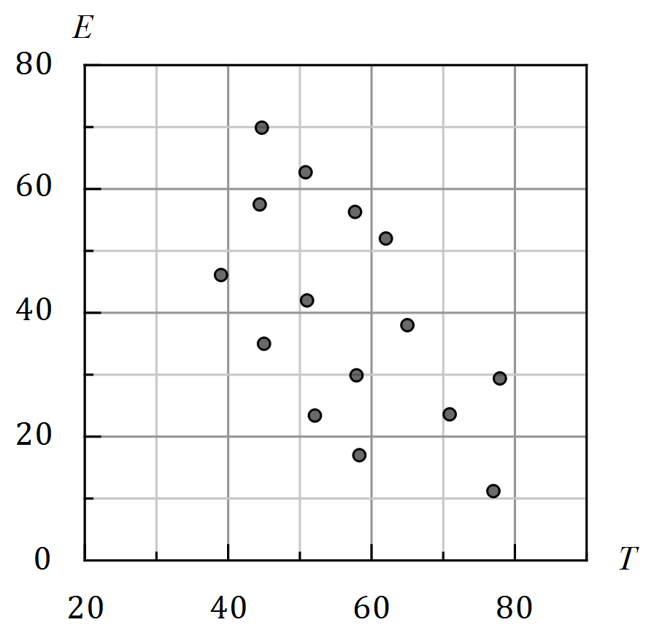

(a) Describe the association between $T$ and $E$ in terms of direction, form and strength.

(3 marks)

(b) Estimate, to one decimal place, the value of the correlation coefficient between the variables and hence determine the percentage of the variation in the error scores that can be explained by the variation in the practice times for this sample. (2 marks)

Question 2 (7 marks)

The vertices on the graph below represent nine pumping stations. The edge weights are the number of hours required to install new electrical cabling between connected stations.

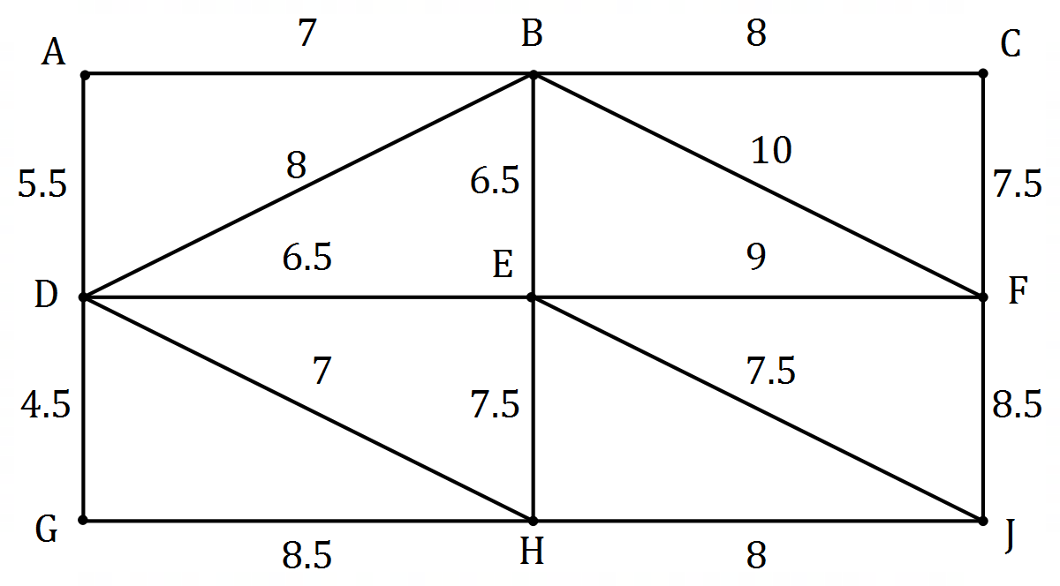

(a) Clearly show the minimum spanning tree on the graph. (2 marks)

A contractor charges $\$200$ per hour to install the cabling.

(b) Determine the cost to install new electrical cabling using the minimum spanning tree.

(2 marks)

(c) A tenth pumping station $K$ is to be included. The time to install cable between $K$ and $B$  
is $5.5$ hours and between $K$ and $F$ is $6.5$ hours.

(i) Use this information to add pumping station $K$ to the graph above. (1 mark)

(ii) If the new cabling is now installed using the minimum spanning tree that  
includes $K$, determine the extra cost of the installation. (2 marks)

Question 3 (7 marks)

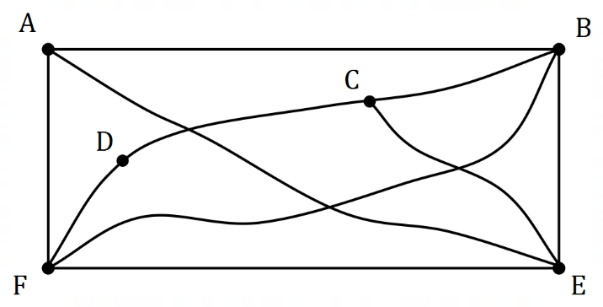Graph $G$ is shown at right.

(a) Adding missing vertices as necessary to those below, draw graph $G$ in the plane, to clearly show that it is planar. (2 marks)

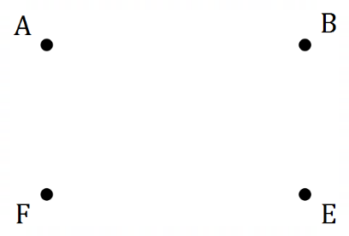

(b) Show that graph $G$ satisfies Euler's formula. (2 marks)

(c) Graph $G$ is semi-Eulerian. Describe two features of the trail it contains to be classified as semi-Eulerian. (2 marks)

(d) Describe where an edge can be added to graph $G$ so that it contains an Eulerian trail.

(1 mark)

Question 4 (6 marks)

Arif, Brenton, Carter and Dana have been chosen for the $4×50$ m medley relay team in a swimming carnival. This relay is swum by four different swimmers, each swimming one of four different strokes. Their best times, in seconds, to swim $50$ m freestyle, backstroke, breaststroke and butterfly are shown in the following table.

|  |  |  |  |  |
| --- | --- | --- | --- | --- |
|  | Freestyle | Backstroke | Breaststroke | Butterfly |
| Arif | $$32$$ | $$42$$ | $$36$$ | $$35$$ |
| Brenton | $$33$$ | $$43$$ | $$38$$ | $$37$$ |
| Carter | $$31$$ | $$42$$ | $$36$$ | $$35$$ |
| Dana | $$32$$ | $$41$$ | $$35$$ | $$36$$ |

(a) Show use of the Hungarian algorithm to determine which stroke each boy should swim so that the team completes the $4×50$ m medley relay in the shortest possible time.

(4 marks)

(b) The record for the $4×50$ m medley relay is $2$ minutes and $23$ seconds. If all the boys swim their assigned leg in their best time, will they break the record? Justify your answer.

(2 marks)

Question 5 (8 marks)

A directed subgraph of a distribution network is shown below. The vertices represent distribution centres and the weight on each edge is the maximum volume of parcels, in cubic metres, that can be transported from one distribution centre to another every day.

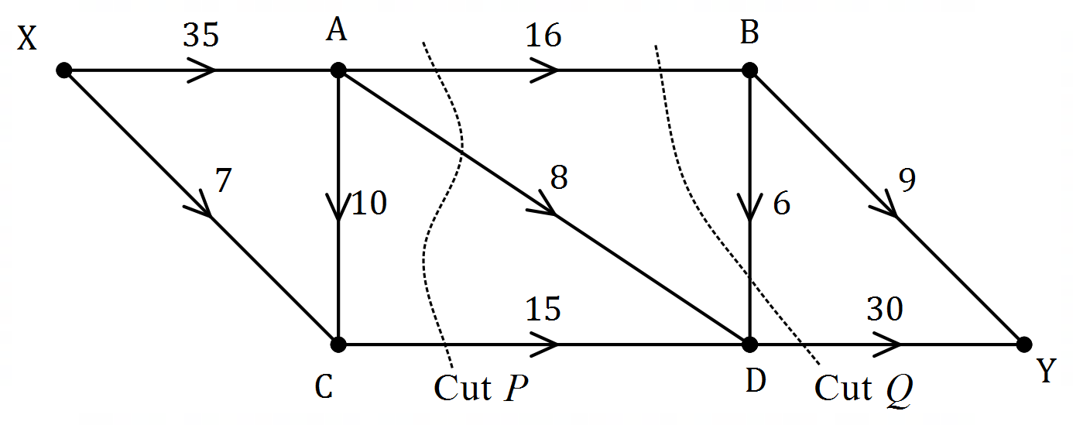

(a) Determine the capacity of cut $P$ and the capacity of cut $Q$ shown above. (2 marks)

(b) Determine the maximum volume of parcels that can be transported

(i) from centre X to centre C in a day. (1 mark)

(ii) from centre A to centre D in $5$ days. (2 marks)

(c) Determine the maximum volume of parcels that can be transported from centre X to centre Y in $10$ days. (3 marks)

Question 6 (6 marks)

A linear model was fitted to datasets $P, Q$ and $R$ and the resulting residual plot for each model shown below. Dataset $P$ has a non-linear form whereas datasets $Q$ and $R$ have linear form.

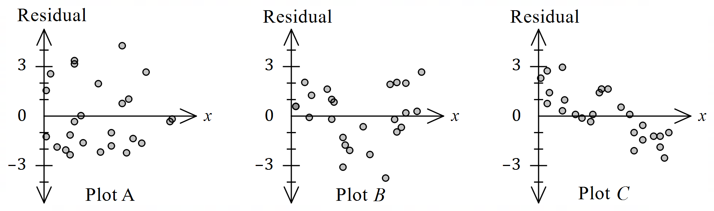

It is also known that the linear model was incorrectly fitted to dataset $Q$.

(a) State, with justification, which residual plot is most likely to be derived from dataset $P$.

(2 marks)

(b) State, with justification, which residual plot is most likely to be derived from dataset $Q$.

(2 marks)

(c) State, with justification, which residual plot is most likely to be derived from dataset $R$.

(2 marks)

Question 7 (6 marks)

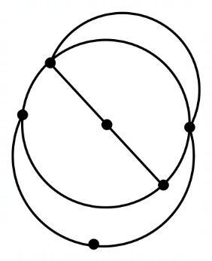Graph $G$ is shown.

It represents a communication  
network of a group of six diplomats.

(a) State, with reasons, if graph $G$ is a simple graph. (2 marks)

(b) For graph $G$, determine the length of the longest

(i) closed trail it contains. (1 mark)

(ii) open path it contains. (1 mark)

(c) Explain why graph $G$ is a Hamiltonian graph. (2 marks)

Question 8 (7 marks)

A project involves the completion of activities $A$ to $H$, as shown in the following table. Note that only three of the activity durations are shown.

|  |  |  |  |  |  |  |  |  |
| --- | --- | --- | --- | --- | --- | --- | --- | --- |
| Activity | $$A$$ | $$B$$ | $$C$$ | $$D$$ | $$E$$ | $$F$$ | $$G$$ | $$H$$ |
| Immediate predecessor(s) | $$-$$ | $$-$$ | $$A$$ | $$A$$ | $$B$$ | $$B$$ | $$D, E$$ | $$E, F$$ |
| Duration (weeks) |  | $$9$$ | $$24$$ |  |  |  | $$13$$ |  |
| Float (weeks) | $$2$$ | $$0$$ | $$11$$ | $$2$$ | $$0$$ | $$9$$ | $$0$$ | $$4$$ |

The minimum completion time for the project is $38$ weeks.

(a) Construct an activity network to represent the above information. (3 marks)

(c) List the tasks that lie on the critical path. (1 mark)

(b) Determine a possible duration for each of the activities $A, D, E, F$ and $H$. (3 marks)

Supplementary page

Question number: _________

© 2020 WA Exam Papers. Kennedy Baptist College has a non-exclusive licence to copy and communicate this document for non-commercial, educational use within the school. No other copying, communication or use is permitted without the express written permission of WA Exam Papers. SN245-166-1.